**EX.NO:6**

**Reg.no:220701012**

**INTRODUCTION TO PROLOG**

**AIM:** To learn PROLOG terminologies and write basic programs**.**

**CODE:**

**KB1:**

woman(mia).

woman(jody).

woman(yolanda).

playsAirGuitar(jody).

party.

Query 1: ?-woman(mia).

Query 2: ?-playsAirGuitar(mia).

Query 3: ?-party.

Query 4: ?-concert.

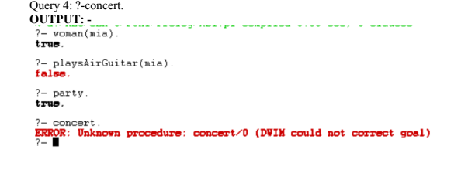

**KB2:**

happy(yolanda).

listens2music(mia).

Listens2music(yolanda):-happy(yolanda).

playsAirGuitar(mia):-listens2music(mia).

playsAirGuitar(Yolanda):-listens2music(yolanda).

**OUTPUT: -**

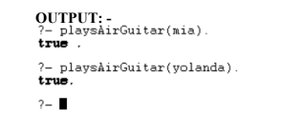

**KB3:**

likes(dan,sally).

likes(sally,dan).

likes(john,brittney).

married(X,Y) :- likes(X,Y) , likes(Y,X).

friends(X,Y) :- likes(X,Y) ; likes(Y,X).

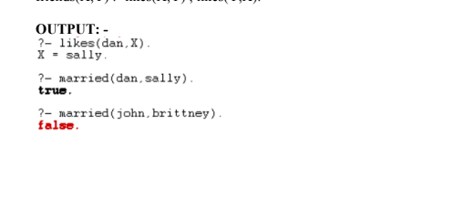

**KB4:**

food(burger).

food(sandwich).

food(pizza).

lunch(sandwich).

dinner(pizza).

meal(X):

-food(X).  
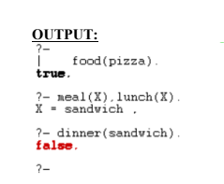  
  
**KB5:**

owns(jack,car(bmw)).

owns(john,car(chevy)).

owns(olivia,car(civic)).

owns(jane,car(chevy)).

sedan(car(bmw)).

sedan(car(civic)).

truck(car(chevy)).  
  
  
